NPC – Unit 4 Assignment
Topic: Configure DHCP and Set Up a Network Using Cisco Packet Tracer

Submitted By
Name: Kunal Kailas Kulkarni
PRN: 2125UCSM1078
Department: Cybersecurity
Course: Network Protocol Configuration (Fortinet)
Course Code: 24UCYPC201
Academic Year: 2026–27

Objective
The objective of this mini-project is to configure a DHCP server in Cisco Packet Tracer, allow client PCs to obtain IP addresses automatically from it, and verify communication between the clients using the ping command.

Software Used
Cisco Packet Tracer.

Network Topology
The network consists of one server (Server0), one Cisco 2960 switch (Switch0), and three client PCs (PC0, PC1, and PC2). All devices are connected using copper straight-through cables. No router is used because all devices are in a single local subnet.

From | Port | To | Port
Server0 | FastEthernet0 | Switch0 | FastEthernet0/1
PC0 | FastEthernet0 | Switch0 | FastEthernet0/2
PC1 | FastEthernet0 | Switch0 | FastEthernet0/3
PC2 | FastEthernet0 | Switch0 | FastEthernet0/4

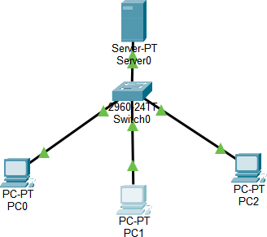

Figure 1: Network topology.

IP Addressing
The server is configured with a static IP address, while the client PCs obtain their addresses automatically from the DHCP server.

Device | IP Address | Subnet Mask | Method
Server0 | 192.168.2.2 | 255.255.255.0 | Static
PC0 | 192.168.2.100 | 255.255.255.0 | DHCP
PC1 | 192.168.2.101 | 255.255.255.0 | DHCP
PC2 | 192.168.2.102 | 255.255.255.0 | DHCP

The default gateway and DNS server are set to 0.0.0.0 because this network has no router or separate DNS server.

Procedure
Step 1: Create the Network Topology

One Server-PT device, one Cisco 2960 switch, and three PC-PT devices were placed in the Packet Tracer workspace. All devices were connected using copper straight-through cables according to the topology table. The link lights were checked to ensure that the connections were active.

Step 2: Configure the Server's Static IP Address
On Server0, the Desktop → IP Configuration section was opened. The Static option was selected, and the following values were entered:

Setting | Value
IPv4 Address | 192.168.2.2
Subnet Mask | 255.255.255.0
Default Gateway | Left blank
DNS Server | Left blank

A static IP address was assigned to the server so that it could be accessed consistently by the client devices.

Step 3: Configure the DHCP Service
On Server0, the Services → DHCP section was opened, and the DHCP service was switched On. A pool named LAN_POOL was created with the following configuration:

Setting | Value
Pool Name | LAN_POOL
Default Gateway | 0.0.0.0
DNS Server | 0.0.0.0

Start IP Address | 192.168.2.100
Subnet Mask | 255.255.255.0
Maximum Number of Users | 50

Initially, the default pool named serverPool could not be removed or edited using the available controls, and PC0 received the address 192.168.2.1. To resolve the issue, serverPool was subsequently configured to use the same start address, 192.168.2.100, and a maximum of 50 users. The changes were saved, and the client PCs subsequently received the intended addresses.

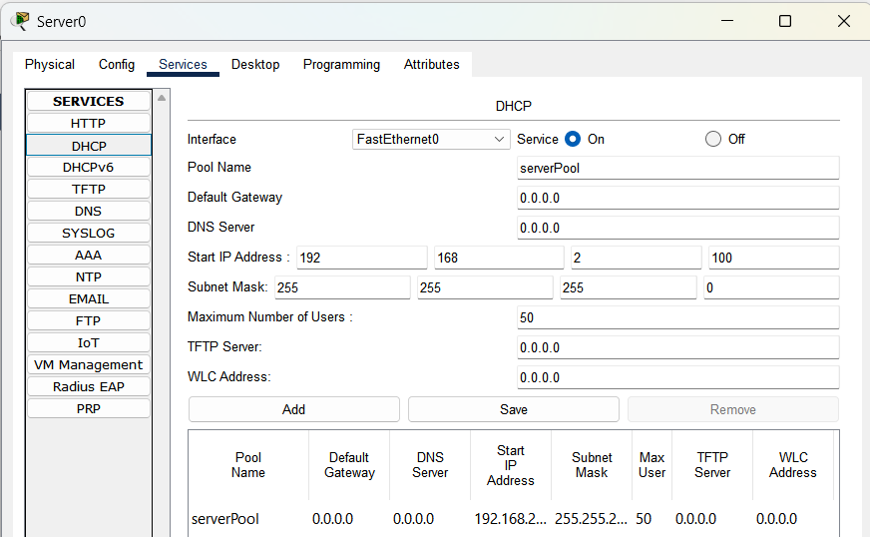
Figure 2: DHCP server configuration.

Step 4: Configure the Client PCs
Each client PC was configured to obtain its IP address automatically. The following steps were performed on PC0, PC1, and PC2:

- Open the PC device.
- Select Desktop → IP Configuration.
- Select DHCP.
- Wait for the message “DHCP request successful”.
- Verify the assigned IPv4 address and subnet mask. The client PCs received the following IP addresses:

Device | Assigned IP Address | Subnet Mask
PC0 | 192.168.2.100 | 255.255.255.0
PC1 | 192.168.2.101 | 255.255.255.0
PC2 | 192.168.2.102 | 255.255.255.0
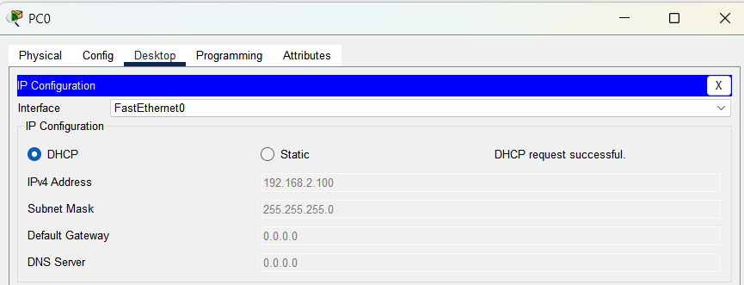
Figure 3: IP address assigned to PC0 using DHCP.

Step 5: Verify the IP Configuration
The ipconfig command was executed in the Command Prompt on each client PC to verify the assigned IPv4 address and subnet mask.
The command used was: ipconfig

Each PC showed a unique IPv4 address in the 192.168.2.0/24 network with the subnet mask 255.255.255.0.

Connectivity Testing
Connectivity was tested from PC0 using the ping command. PC0 sent ping requests to PC1 at 192.168.2.101 and PC2 at 192.168.2.102.
The following commands were executed:
ping 192.168.2.101
ping 192.168.2.102
These commands were used to verify communication between the client PCs within the local network.

Ping Results
The connectivity test results are summarized below.

Test | Result
PC0 receives an IP address using DHCP | Successful —  192.168.2.100
PC1 receives an IP address using DHCP | Successful —  192.168.2.101
PC2 receives an IP address using DHCP | Successful —  192.168.2.102
PC0 pings PC1 at 192.168.2.101 | 4 sent, 4 received, 0% loss
PC0 pings PC2 at 192.168.2.102 | 4 sent, 4 received, 0% loss

The ping tests confirmed that PC0 could communicate successfully with both PC1 and PC2. Both tests completed with zero packet loss.

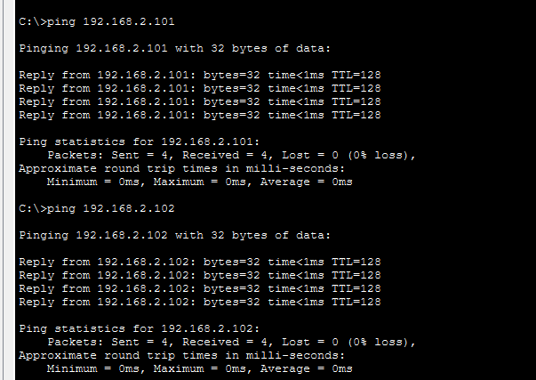
Figure 4: Successful ping replies from PC0 to PC1 and PC2.

Summary
A DHCP server was configured on Server0 with an address pool starting at 192.168.2.100. The three client PCs obtained their IP addresses automatically, and each received a unique address in the 192.168.2.0/24 subnet. The default pool, serverPool, was reconfigured during troubleshooting to match the intended address range. The ping tests confirmed that the PCs could communicate successfully over the local network.

Result
The DHCP server was successfully configured in Cisco Packet Tracer. PC0, PC1, and PC2 received the IP addresses 192.168.2.100, 192.168.2.101, and 192.168.2.102, respectively. The ping tests from PC0 to PC1 and PC2 showed four successful replies each, with 0% packet loss.

Conclusion
This mini-project demonstrated how DHCP automates IP address assignment in a network. Using a DHCP server eliminates the need to configure each client manually, helps prevent duplicate IP addresses, and simplifies network management. The successful ping results confirmed that the tested devices were correctly configured and could communicate within the same local subnet.

****

